Bismillahir-Rahmanir-Raheem By the Grace of God 

THE EAST LONDON
THREE FAITHS FORUM
OUR NINTH GUIDED TOUR TO
JERUSALEM AND THE HOLY LAND
Sunday 5th December – Sunday 12th December 2021
Led by: Rabbi David Hulbert, Revd. Richard Wyber & Imam Dr. Mohammed Fahim

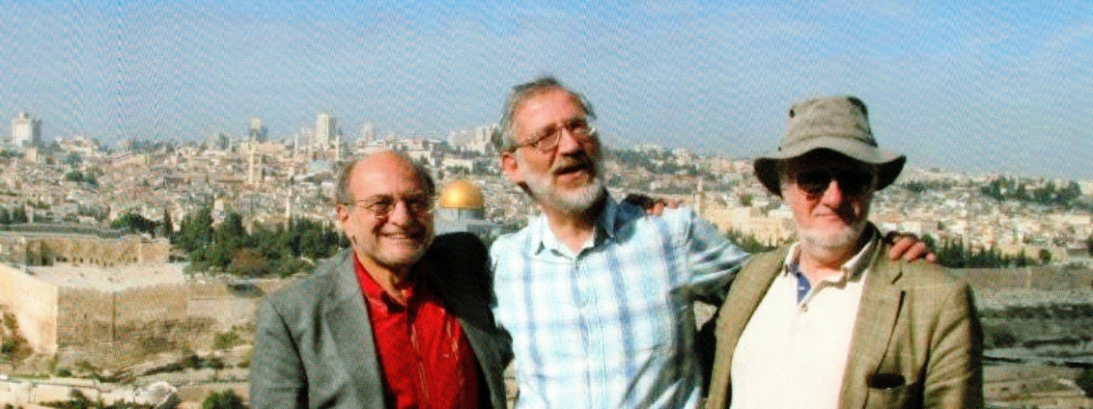

Don’t miss this once-in-a-lifetime opportunity to visit places in the Holy Land (both Israel and the Palestinian territories) sacred to our three faiths:
Jerusalem Al-Aqsa Mosque and Dome of the Rock
Church of the Holy Sepulchre (Jesus’ tomb)
Western Wall
Yad Vashem (Memorial to Holocaust victims)
Bethlehem Jesus’ birthplace
Hebron Tombs of the Patriarchs
Nazareth Jesus’ home-town; site of the angel Gabriel’s announcement to Mary
Caesarea Capital of Judaea and major port in Roman times
Boat-trip across the Sea of Galilee
And many more!
COST £1,500 per person, sharing twin room.
Includes:
Return coach from Woodford to Luton & Gatwick Airports
Return flights
Half-board in top-quality, modern hotels
Travel in comfortable air-conditioned tour coach
Qualified tour guide, with us for the whole week
All entrance fees
The cost is made up of a deposit of £300, payable immediately, that will buy your EasyJet ticket. The flight tickets will go up in price as the plane fills up, so it is important to commit yourself and secure this price as soon as you can.
The balance of £1,200, covering the hotels and the tour, will be payable at the beginning of November. This price is unlikely to change, unless there is a major change in the value of the £ against the $.
If you would like to come, please send your name and full postal address to: david.hulbert@whsmithnet.co.uk and you will be sent all the details and the booking form, with full terms and conditions.

FURTHER DETAILS:

The Middle East is the cradle of all three Abrahamic faiths and Israel/Palestine is full of holy places sacred to all three faiths. Jerusalem is a holy city, a place of pilgrimage for Jews, Christians and Muslims. The magnificent Dome of The Rock is the earliest mosque in the world, marking the Night Journey of the Prophet from Makka. Many of the present-day inhabitants of the Holy Land are still guided by their religious faith in their lives. Visiting the Holy Land, and praying to God there, in the company of other people of faith, is the journey of a lifetime.
This tour will be led by Rabbi David Hulbert, Revd. Richard Wyber & Imam Dr. Mohammed Fahim. The itinerary mostly duplicates those of our earlier eight very successful visits, and we will be led by a professional and licensed tour guide.
We have tried to include as many significant sites of religious pilgrimage as possible in the seven days available, and we have also tried to achieve a good balance of sites of Jewish, Christian and Muslim interest. But members of the Three Faiths Forum will recognise that the trip is an opportunity to learn about the holy sites of the other two faiths, as well as venerating their own. The weather will be warm and beautiful. Although the tour is quite intensive, there will be some free time and there will be plenty of opportunities to nap on the coach!

BACKGROUND INFORMATION
- Tourist visas are normally granted to British passport holders on entry to the country. You must have at least six months’ validity left on your passport after the end of Dec. 2021. Please check now! For those who wish to use their passports to visit countries such as Pakistan, you can be assured that the border control people will put entry and exit stamps on a separate, removable piece of paper in your passport.
- You should expect very stringent security checks, both at Luton and upon arrival in Israel. Please be calm and patient!
- You do not need any medical jabs. Drinking water is safe. Just pack some Diocalm to soothe ‘holiday tummy’.
- You do not need to take travellers’ cheques or cash - there are plenty of cash machines that work with British credit or debit cards.
- Food is ‘Mediterranean’, with plenty of dairy food, fresh salads and rice. All meat will be kasher/halal. Hotels operate an ‘eat as much as you want’ buffet service.
- Prices are much the same as they are in Britain. You are expected to bargain for souvenirs in Arab shuks, although Israeli prices are fixed.
- As part of a guided coach tour, you are expected to be punctual for all departures, especially first thing in the morning! You will be expected to keep with the group, and not wander off to ‘do your own thing’ - although there will be free time and time for regular prayers.

POST- CORONAVIRUS

As you know, at the time of writing, both Israel and the UK have vaccinated a high proportion of their populations and levels of infection are currently very low. So tourist travel between the two countries is likely to be reopened. Israel is likely to be on the ‘Green List’ to be announced on May 17th.

But we assume that individuals will only be allowed to enter Israel and Palestine if they can show that they have been vaccinated or tests show that they are free from the virus. Obviously the situation may change in the seven months before December. We do not at present know if we will have to pay for tests on entry and exit, or how much tests might cost.

Please be assured that costs for flights and the tour will be refunded if, for whatever reason, we cannot go ahead. You will be kept informed of developments.

